GENERAL CONDITIONS
- Entries are free and open to all financial members of the Redlands Orchid Society Inc. and members of other Orchid Societies affiliated with Queensland Orchid Society Inc. (QOS) and/or Australian Orchid Council Inc. (AOC).
- All growers benching and/or selling plants must list their details in the Fire Ant Register prior to benching.
- All exhibits are to be tabled by 7.00 pm on judging night. Once tabled, no plant can be moved or touched without the express consent of the chief steward. All persons not associated with judging must leave the show area before the commencement of judging at 7.30pm.
- Individual plants may be entered into one class only. All plants entered must be in show condition.
- A specimen plant shall mean a mature plant which has been developed from a single clone and shows evidence of good culture over a considerable time.
- Plants entered shall have been owned and grown by the exhibitor for the preceding 6 months.
- The Chief Steward, in conjunction with other Committee members, shall have the right to refuse the exhibition of any plant which appears to be diseased and/or infested with pests. This equally applies to any plant offered for sale.
- Exhibitors are responsible for ensuring all their plants benched are clearly and legibly labelled with the correct plant name and exhibitor’s number on the Redlands Orchid Society benched plant label.
- Although it is the responsibility of the exhibitor to enter the plant in the correct class and place it in a suitable position on the competitive bench, the Chief Steward has the right to determine the class in which any plant may be exhibited; to reject or rearrange any entry; and to combine and/or establish extra classes if needed.
- A seedling shall mean the complete plant grown from seed and flowering for the first time. For exhibition purposes, seedlings retain their status of ‘seedling’ throughout the flowering season in which they first flower. An Orchid developed by a meristem process will be excluded.
- Staking and tying will be permitted in accordance with Australian Orchid Council Inc. (AOC) standards.
- Orchids benched in Group of Three Orchids Class to be judged as a group only, and not judged individually.
- The judges shall select the winners of the Champion Awards from all plants on display, excluding Novice Classes, commercial displays and invited club displays.
- Judging of the winners of the Champions Awards to be carried out after all class sections have been judged. Champions will be judged by the complete judging panel.
- The judges’ decision shall be final.
- No flower or pollen is to be removed from any exhibit. The unauthorized removal of any flower, pollen, or plant may lead to the initiation of legal action.
- The Redlands Orchid Society Inc., or its agents, will accept no responsibility for theft, loss, destruction of plants or damage of any kind occasioned to plants either during transport to or from the show venue, or while at the show venue either for exhibition, display or sale purposes.
- Photographs may be taken at any time, but not at the inconvenience of other show patrons.
- A condition of acceptance of any entry will be that the exhibitor agrees to be bound by the General Conditions described herein, and to the rules and by-laws of the Redlands Orchid Society Inc.
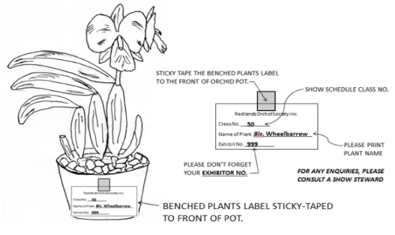

HOW TO LABEL YOUR BENCHED PLANTS:

REDANDS ORCHID SOCIETY INC
AUTUMN 2023 CHARITY ORCHID SHOW SCHEDULE
Supporting Redland Hospital Auxiliary
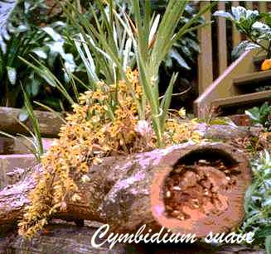

Saturday, 20th April 2024
8.30am to 3.00pm
Birkdale Sports Club
Judy Holt Park, Randall & Bailey Roads, Birkdale

CHAMPION OF SHOW President’s Trophy $150.00
(Sponsored by Brisbane Orchid Supplies)
RESERVE CHAMPION $100.00

CHAMPION SPECIMEN $75.00

CHAMPION SPECIES (Classes F1 - F7) ** $75.00

CHAMPION CATTLEYA HYBRID (Classes A1 - A7) ** $50.00

CHAMPION PAPHIOPEDILUM ALLIANCE HYBRID (Classes B1 - B3) ** $50.00

CHAMPION VANDACEAE HYBRID (Classes C1 - C3) ** $50.00

CHAMPION DENBROBIUM HYBRID (Classes E1 - E8) ** $50.00

CHAMPION ANY OTHER GENERA HYBRID (Classes G1 – G4) ** $50.00

CHAMPION NOVICE (Classes H1 & H2) $50.00
(Novice open to Redlands Orchid Society Members Only - Perpetual Trophy Sponsored by Fame Orchids)
** The exhibit chosen as First Prize for Orchid Seedling First Flowering is to be considered for
Champion Award if it qualifies.

CLASS PRIZES – VOUCHERS 1st $20.00 2nd $15.00 3rd $10.00
MOST SUCCESSFUL REDLANDS ORCHID SOCIETY MEMBER EXHIBITOR
The Eddie Santaguiliana Memorial Trophy
SHOW SCHEDULE – AUTUMN 2024 CHARITY ORCHID SHOW

Benching from 4.00pm Friday, 19th April 2024
0
5
60
70
80
90
100

Champion Cattleya Hybrid
A1 Cattleya Alliance* Hybrid - Exhibition Type - Predominantly White over 110mm
A2 Cattleya Alliance* Hybrid - Exhibition Type - Mauve, Pink, Purple over 110mm
A3 Cattleya Alliance* Hybrid - Exhibition Type - Any Other Colour over 110mm
A4 Cattleya Alliance* Hybrid - Exhibition Type (Miniature - Blooms up to 70mm)
A5 Cattleya Alliance* Hybrid - Exhibition Type (Compact - Blooms 70mm to 110mm)
A6 Cattleya Alliance* Hybrid - Cluster Type - (5 or more open flowers per stem)
A7 Cattleya Alliance* Hybrid - Not included elsewhere
Alliance* = B., S., L., C., Rl., Gur. or combination thereof.

Champion Paphiopedilum Alliance Hybrid
B1 Paphiopedilum Hybrid - Primary (Names of species involved must be shown)
B2 Paphiopedilum Hybrid - Any Other Type
B3 Phragmipedium Hybrid -

Champion Vandaceae Hybrid
C1 Vandaceous Alliance Hybrid - Vanda (Exhibits of one cut spike allowed)
C2 Vandaceous Alliance Hybrid - Intergeneric (Exhibits of one cut spike allowed)
C3 Phalaenopsis Hybrid - Any Type

Champion Dendrobium Hybrid
E1 Dendrobium Hybrid - Australian Native
E2 Dendrobium Hybrid - Phalaenanthe Type - White/Bicolour
E3 Dendrobium Hybrid - Phalaenanthe Type - Dark
E4 Dendrobium Hybrid - Phalaenanthe Type - Light Pink
E5 Dendrobium Hybrid - Phalaenanthe Type - Striped
E6 Dendrobium Hybrid - Phalaenanthe Type - Miniature (Under 50mm)
E7 Dendrobium Hybrid - Intermediate Type
E8 Dendrobium Hybrid - Any Other Type (Not included elsewhere)

Champion Any Other Genera Hybrid
G1 Oncidiae Hybrid - Including Oncidium Alliance
G2 Epidendrum Hybrid - Crucifix Type (One cut spike per exhibit allowed)
G3 Bulbophyllum Hybrid -
G4 Any Other Genera - Hybrid (Not included elsewhere)

Orchid Seedling First Flowering
S1 Orchid Seedling - First flowering - see Condition J

Champion Species
F1 Species - Cattleya Alliance
F2 Species - Paphiopedilum and Phragmipedium
F3 Species - Dendrobium
F4 Species - Australian Native
F5 Species - Vandaceae (including Phalaenopsis)
F6 Species - Bulbophyllum
F7 Species - Any Other Genera

Champion Novice (Open to Redlands Orchid Society members only)
H1 Hybrid - Any Genera
H2 Species - Any Genera
H3 Hybrid - Dendrobium

Floral Art
J1 Corsage
J2 Arrangement Theme: ‘ANZAC”
Accessories permitted/no flowers other than orchids.

Display
M1 Group of Three Orchids - Three Distinct Genera Required

For further information, contact Secretary 0414 738 110
Email redlandsorchidsociety@hotmail.com
PO Box 818 Capalaba Q 4157

Presentation of Trophies and Prizes will be at
3.00pm Saturday, 20th April 2024
following the drawing of the Raffles

Redlands Orchid Society Inc. wishes to thank
Bendigo Community Bank, Fame Orchids, Brisbane Orchid Supplies, Redlands City Council, Redlands RSL and
Society Members for participating and for donation of prizes.

